Creating Django virtual environment and activating it.

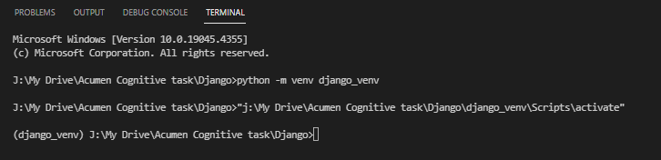

Installing Django

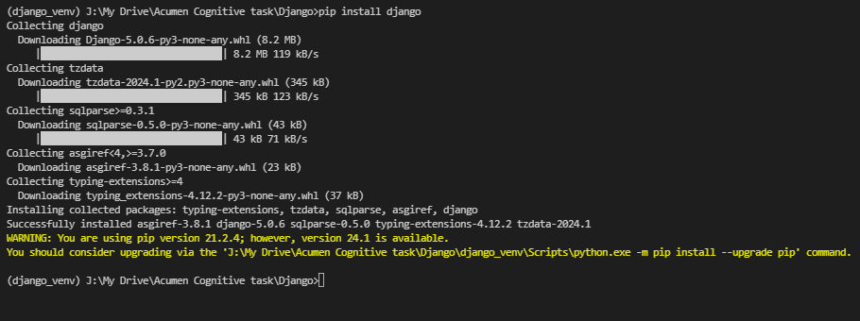

Starting project and creating app

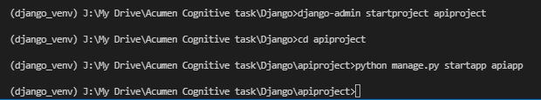

Installing Rest framework

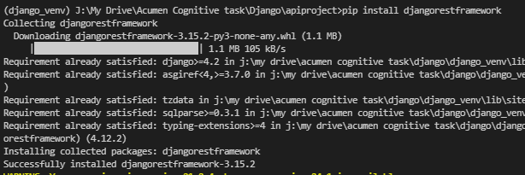

Registering framework and app in settings.py

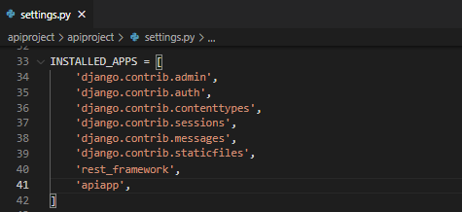

Creating **app_urls.py** in app

Include app_urls at project level in urls.py

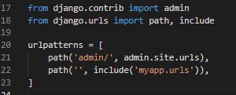

Creating template folder and registering in settings.py

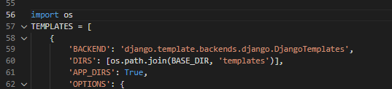

Creating user_form.html in templates

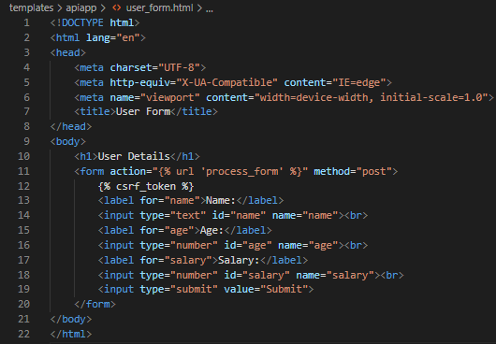

Models.py

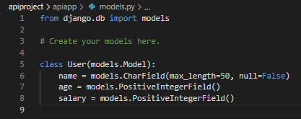

View.py

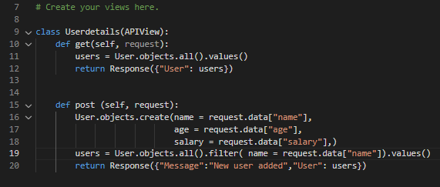

Makemigrations and migrate

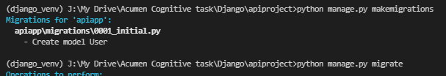

Runserver



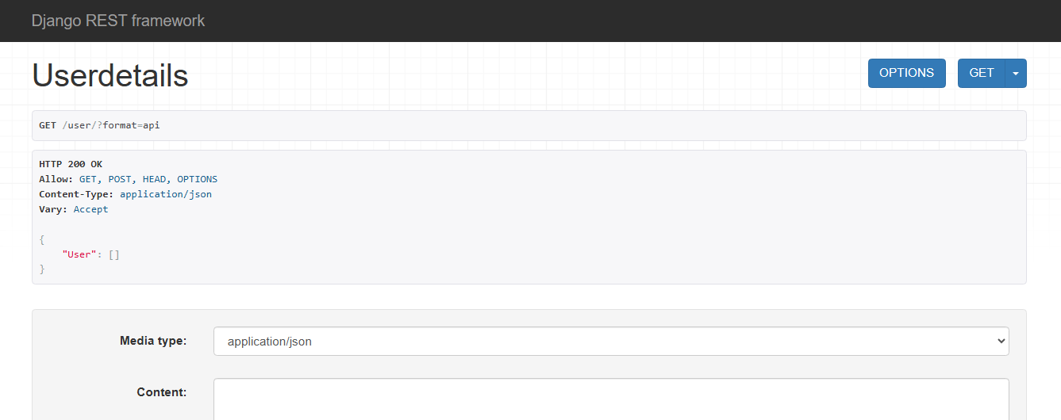

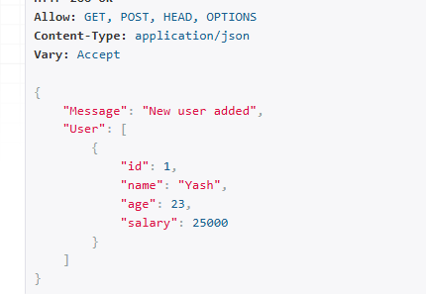

Performing form validation

Creating serializers.py

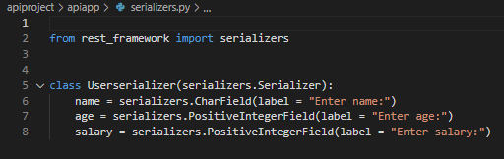

Changes in views.py

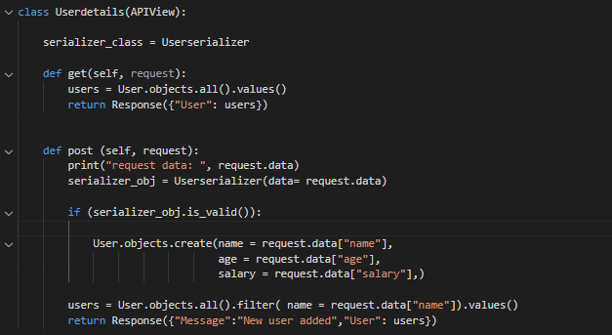

Runserver

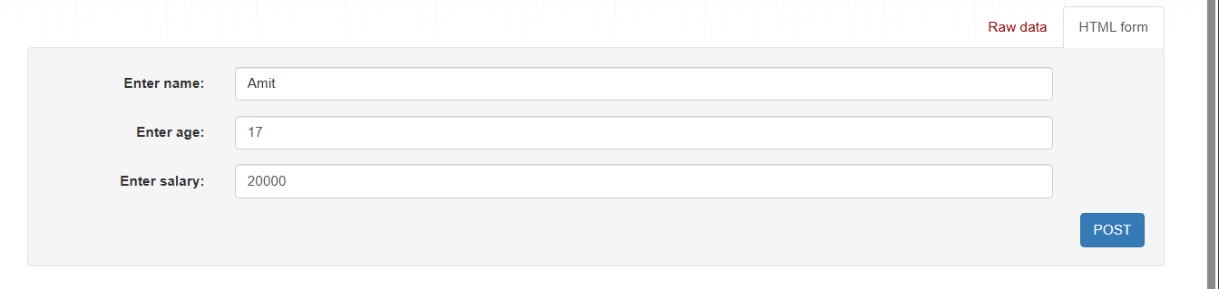

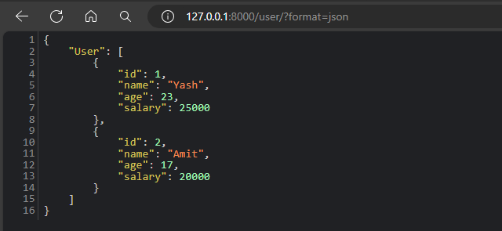

**Submitting task incomplete because of deadline, some errors to be solve**